Computer Networks
2nd Year, 1st Semester
2022

Tutorial 1

- ABC Company just purchased three new routers to start their company network. Which items are needed to establish a terminal session between a PC and the router for the initial configuration?
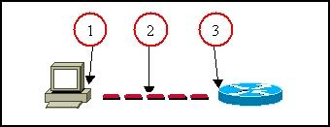

1 – RS232 (RJ 45 to DB 9 Adapter connects to serial port of pc)
2 – Console cable
3- Router’s console port

- State the methods to log to a router.
- Console
- Auxiliary
- Telnet

- Explain the main modes found in the process of configuring the router.
- User Mode
- Privileged Mode
- Configuration Mode

- State the two ways to retrieve previously used commands.
- Press Up and Down arrow
- Command : show history

- How do you configure passwords for privilege mode?
Which password takes precedence?
- Normal password – Router(config)# enable password SLIIT
- Secret password – Router(config)# enable secret Malabe
- Higher precedence – Secret password (because password is encrypted)

- What are the functions of the RAM?

- Store running and active configuration

- Which keystrokes can be used to return to the privileged mode from the interface configuration mode?
- Ctrl + z
- Command - exit

- Which router component holds the configuration file when power is lost?
- NVRAM

- How do you view the current configuration of the router?
- Router# show running-config

- State the method of making a permanent copy of the configurations.

- Save the running config file of the router to the startup config file

